How to pull docker image in git bash and how to run images,
Open the docker hub, open the repository see rignt side down heare we have pull command,
Like this,
This is employee-image in ems application,
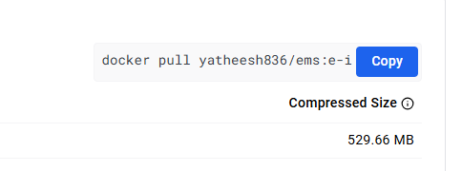

Open the git bash Run this command,
Docker images
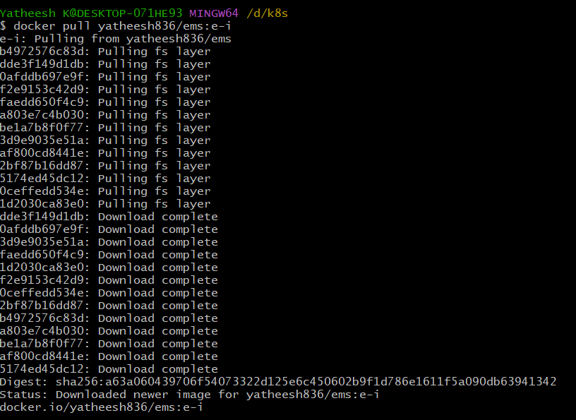

Check images,
Docker images
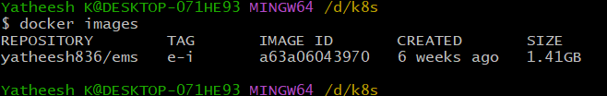

Identity and ui also same procces,
Identity ;

Run this command
Docker pull yatheesh836/ems:identity-i
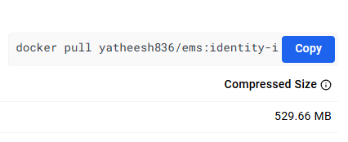

Check image,

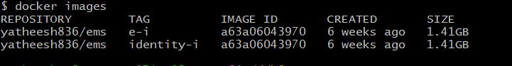

Ui ;
Run this command,
Docker pull yatheesh836/ems:ui-i
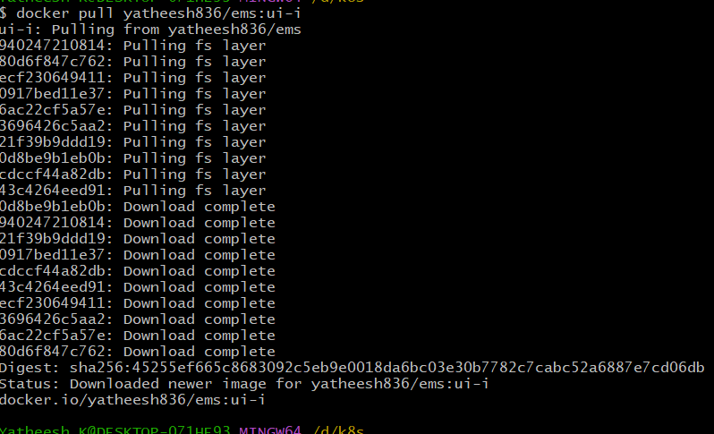

Check images pull or not,
Docker images

See all images,
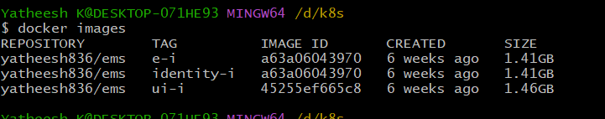

Now how to run docker images,
Ui-image, [4000:4000]
First we need to check the images,
Docker images
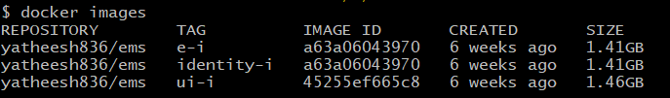
Run the like this,
Docker run -d -p 4000:4000 [image-id]
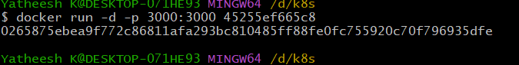

identity-image,
docker run -d -p 4001:4001 [image-id]
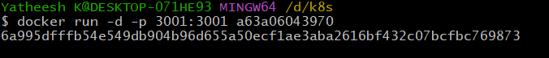

Employee-image,
Docker run -d -p 4002:4002 [image-id]
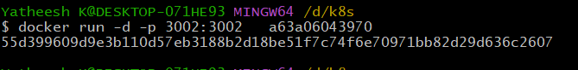

How to docker-compose ;
We need to create docker-compose.yaml file
Vim docker-compose.yaml
Configure the compose.yaml file like this,

services:
ui-image:
image: yatheesh836/ems:ui-i
ports:
- "5000:5000"
networks:
- my_network

identity-image:
image: yatheesh836/ems:identity-i
ports:
- "5001:5001"
networks:
- my_network

employee-image:
image: yatheesh836/ems:e-i
ports:
- "5002:5002"
networks:
- my_network

networks:
my_network:
driver: bridge

then save the file run this command compose-file run,
docker-compose up -d

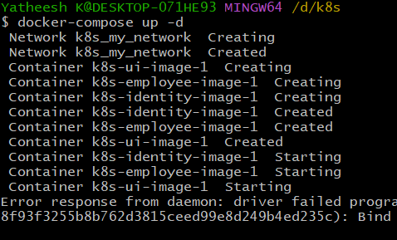
Docker swarm ;

Docker swarm init

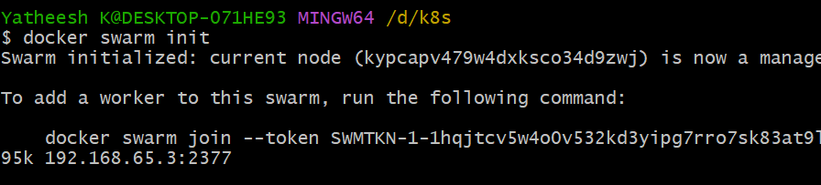

docker-compose.yaml file add this last overlay

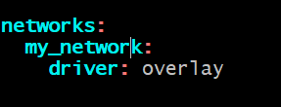

Create mystack containers up,

Commad,

Docker stack deploy -c docker-compose.yaml mystack-ems-app

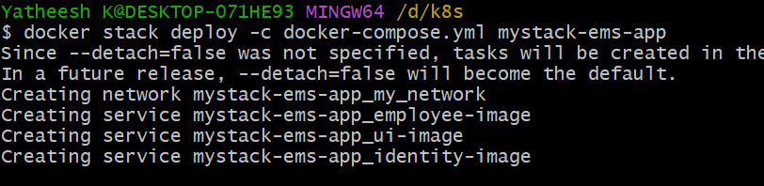

Running containers,
Docker container ls
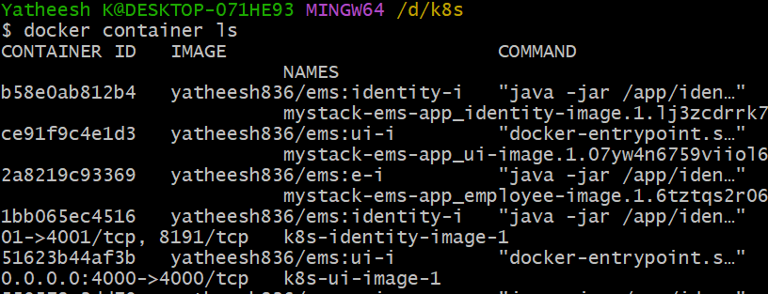

now remove one container then auto uping anather container
docker container rm -f [id]
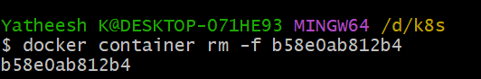

Hear check the identity-image id, changed why it is changed I was remove the identity container, then auto creating new container,
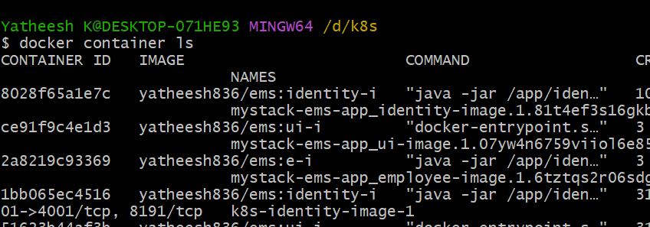
===============#============0=============#====================#

